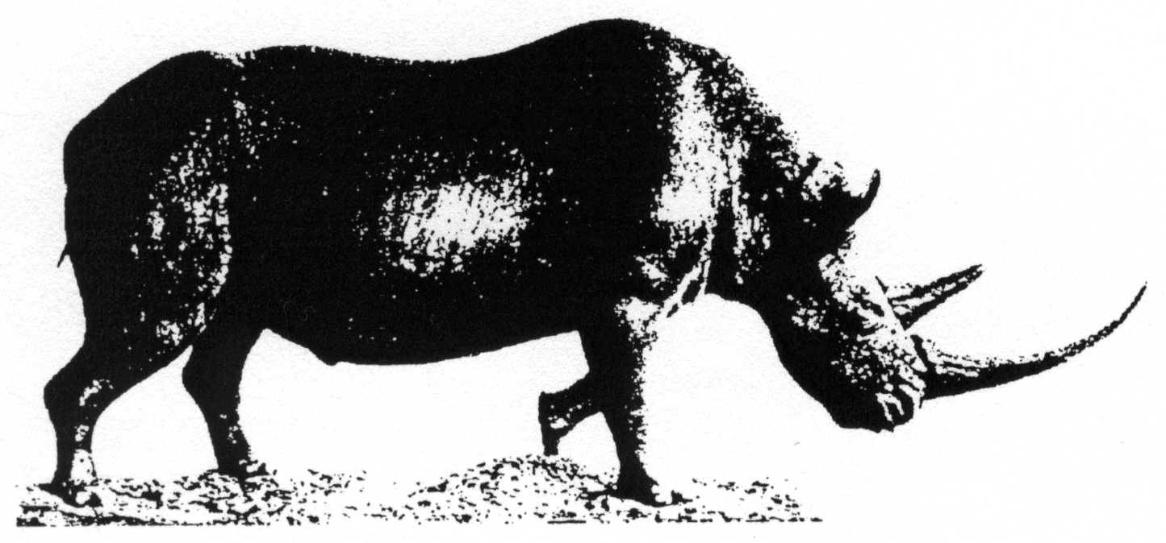 | Acta zoologica cracoviensia
Institute of Systematics and Evolution of Animals, Polish Academy of Sciences
Sławkowska 17, 31-016 Kraków, Poland

Questionnaire for referees
If you find some of the following questions not adequate to the paper reviewed, please omit them.
Please add necessary comments on separate sheets. Please feel free to make editorial and critical remarks directly on your copy of the manuscript.

Title:

1. Has the paper, to the best of your knowledge, been published before,
either in part or in full? YES NO

2. Is the manuscript: properly organised? YES NO
concise? YES NO
clearly written? YES NO

3. Are there any errors of fact? If so, please elaborate. YES NO

4. Do you consider the taxonomy accurate and up-to-date? YES NO

5. Are the interpretations and conclusions sufficiently supported by the data? YES NO

6. Are the illustrations (if any) informative? YES NO
Can some of them be eliminated? YES NO
Are additional illustrations needed? Please specify. YES NO

7. Are the references appropriate and up-to-date? YES NO

8. Indicate your final opinion of the merits of this paper:
...... Acceptable for publication in its present form;
...... Acceptable with minor changes as indicated;
...... Acceptable with major changes (review of revision required);
...... Not acceptable.

9. Would this paper be appropriate for publication in Acta zool. cracov.
after the recommended changes are made? YES NO

Is there anybody else who should see the manuscript before it is accepted for publication? Name:

Date: Signature:

